

**Parent Engagement**

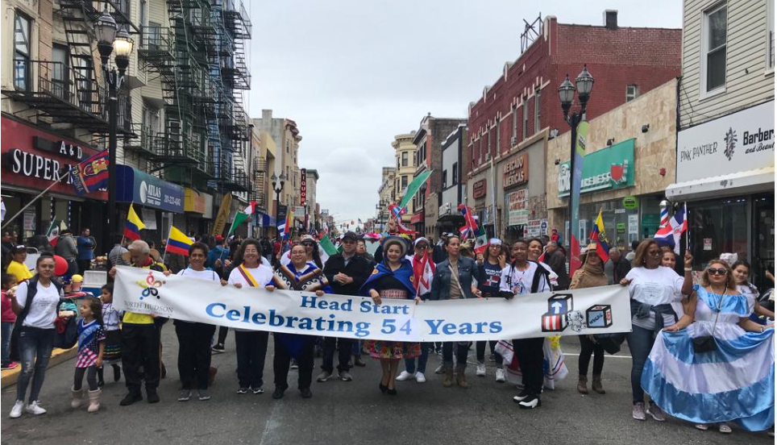

**Facilitate successful program involvement, act as a change agent and assist in successful transition for families throughout their Head Start experience. In addition, Parent Involvement Coordinator are assigned to plan and coordinate functions for the successful delivery of the Programs special initiatives.**

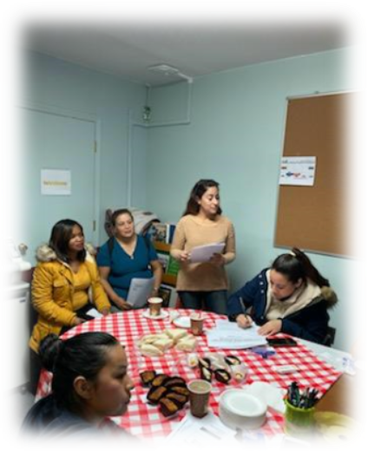 

Head Start emphasizes the importance of Parent involvement and recognizes parents as the primary teacher. You have a great opportunity to collaborate as a Volunteer.





* To serve as a link to parents, the governing body and the community served by the Program.
* Assist the Parent Committee in communicating with all parents enrolled the program with their options to ensure that they understand their rights, responsibilities
* To assist parent communities in planning, coordinating and organizing program activities for parents.
* Assist in recruiting volunteer services.
* To hold monthly meetings where they develop, review, and approve or disapprove policies and procedures regarding all aspects of the program.
* Attending monthly Parent Committee in your Center.
* As Representative Parent Committee, automatically you are a Policy Council Member. Attending monthly Policy Council Meeting.
* Participating Activities Parents.
* Leading Parent Committee

**VOLUNTEERS**

**PARENT COMMITTEE**

**POLICY COUNCIL**